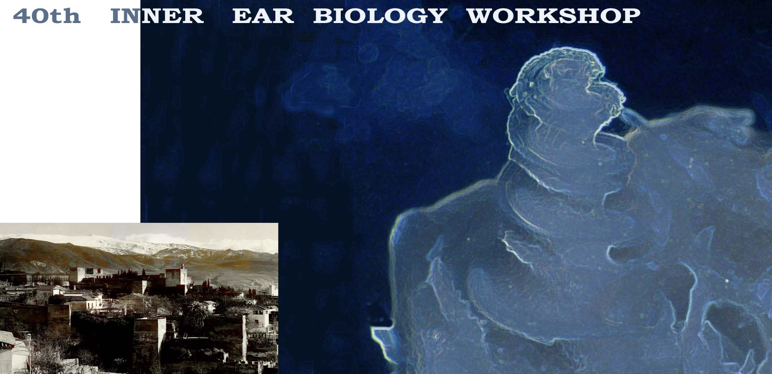
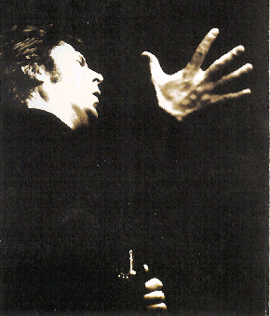

ENRIQUE MORENTE

A real flamenco concert for the

When we accepted to hold this meeting and have you here I wanted to offer you a authentic and alive piece from the Andalucía’s art and feeling, something spontaneous and unique. A real flamenco experience was the obvious choice but it should be far from the stereotype, far from the performances destined to tourists. Then I realized that I had another friend who is a real flamenco master. It is my actual privilege and I want to share it with you. I had admired him since long time ago then he was interested in preserve his larynx and came to me, finally we become friends. I asked him and he immediately accepted to stay a night with us generously postponing (I really know about) important professional offers. I am very grateful for this and proud of it and I know you will appreciate what he really represents. He express as nobody does, what flamenco is. He is an exceptional “cantaor” (flamenco singer) and composer, a creator of the subtle connections among souls through the flamenco which flows from his voice: “cante”. He is for that “venerated” in Andalucía and across the flamenco world.
As it usually is when real flamenco performance and real flamenco master, there is no program. When flamenco people meet late in the night to share time and sing, never a program exists. Things and songs flow naturally around a cup of wine with the help of flamenco guitar. A guitar that delicately pulls out the deepest feelings of the cantaor from his/her soul. That is the flamenco environment where the miracle occurs, and time expands along the night in search of the dawn. This is the andalusian expression of the well known aphorism “Ars longa, vita brevis, ocassio proeceps”. Lets have a piece of it to feel and catch that occasion.

Rafael Urquiza

